System-Level Simulation and Performance Analysis of a Microwave Radar for Target Detection, Range Estimation and Received-Signal Characterization
Aim:
To simulate a microwave radar system and analyze its performance in target detection, range estimation, and received-signal characterization.
Procedure:
- Open MATLAB or suitable radar simulation software.
- Define the radar parameters, including operating frequency, transmitted power, pulse duration, antenna gain, and sampling frequency.
- Model a target at a specified distance and simulate the transmitted and reflected microwave signals.
- Calculate the time delay between the transmitted and received signals to estimate the target range using \(R = \frac{c\tau}{2}\).
- Analyze the received signal using signal-processing techniques to determine its amplitude, noise level, and signal-to-noise ratio (SNR).
- Evaluate the radar performance by examining target detection, range estimation accuracy, and received-signal characteristics.
Code:
clc;
clear;
close all;
%% 1. INPUT PARAMETERS
fc = 10e9; % Radar frequency = 10 GHz
Rtrue = 1000; % Target range = 1000 m
Pt_dBm = 20; % Transmit power = 20 dBm
NF_dB = 5; % Receiver noise figure = 5 dB
B = 10e6; % Receiver bandwidth = 10 MHz
c = 3e8; % Speed of light (m/s)
k = 1.380649e-23; % Boltzmann constant (J/K)
T0 = 290; % Reference temperature (K)
%% 2. ADDITIONAL RADAR ASSUMPTIONS
% These are illustrative assumptions because the question
% does not specify antenna gain or target radar cross-section.
Gt_dBi = 35; % Transmit antenna gain (dBi)
Gr_dBi = 35; % Receive antenna gain (dBi)
sigma = 1; % Target radar cross-section (m^2)
L_dB = 0; % System losses (dB)
Gt = 10^(Gt_dBi/10);
Gr = 10^(Gr_dBi/10);
Pt = 10^((Pt_dBm-30)/10); % Transmit power in watts
lambda = c/fc;
%% 3. RADAR RANGE AND DELAY CALCULATION
tau = 2*Rtrue/c; % Round-trip propagation delay
rangeResolution = c/(2*B);
fprintf('MICROWAVE RADAR SIMULATION\n');
fprintf('--------------------------\n');
fprintf('Carrier frequency : %.2f GHz\n',fc/1e9);
fprintf('Target range : %.2f m\n',Rtrue);
fprintf('Transmit power : %.2f dBm\n',Pt_dBm);
fprintf('Receiver noise figure : %.2f dB\n',NF_dB);
fprintf('Bandwidth : %.2f MHz\n',B/1e6);
fprintf('Wavelength : %.4f m\n',lambda);
fprintf('Round-trip delay : %.4f us\n',tau*1e6);
fprintf('Range resolution : %.2f m\n',rangeResolution);
%% 4. RECEIVED POWER USING RADAR EQUATION
% Monostatic radar equation
Pr = Pt*Gt*Gr*lambda^2*sigma / ...
((4*pi)^3 * Rtrue^4 * 10^(L_dB/10));
Pr_dBm = 10*log10(Pr)+30;
fprintf('\nRECEIVED SIGNAL POWER\n');
fprintf('Received power : %.2f dBm\n',Pr_dBm);
%% 5. RECEIVER NOISE POWER
F = 10^(NF_dB/10);
Pn = k*T0*B*F;
Pn_dBm = 10*log10(Pn)+30;
SNR_dB = Pr_dBm-Pn_dBm;
SNR_linear = 10^(SNR_dB/10);
fprintf('\nNOISE AND SNR ANALYSIS\n');
fprintf('Noise power : %.2f dBm\n',Pn_dBm);
fprintf('Received SNR : %.2f dB\n',SNR_dB)
%% 6. GENERATE TRANSMITTED LFM PULSE
% Complex baseband linear frequency-modulated pulse
Fs = 20e6; % Sampling frequency = 20 MHz
Tp = 2e-6; % Pulse duration = 2 us
Ns = round(Tp*Fs);
tPulse = (0:Ns-1)/Fs;
chirpRate = B/Tp;
tx = exp(1j*pi*chirpRate*(tPulse-Tp/2).^2);
% Normalize pulse to unit average power
tx = tx/sqrt(mean(abs(tx).^2));
%% 7. SIMULATE RECEIVED ECHO
Tsim = 12e-6;
N = round(Tsim*Fs);
t = (0:N-1)/Fs;
rx = zeros(1,N);
delaySamples = round(tau*Fs);
startIndex = delaySamples+1;
endIndex = startIndex+Ns-1;
% Received echo amplitude is determined by radar equation
echoAmplitude = sqrt(Pr);
if endIndex <= N
rx(startIndex:endIndex) = echoAmplitude*tx;
else
error('Increase simulation duration to include the full echo.');
end
%% 8. ADD RECEIVER THERMAL NOISE
% Complex Gaussian noise with total power k*T0*B*F
rng(1); % Repeatable simulation
noise = sqrt(Pn/2) * ...
(randn(1,N)+1j*randn(1,N));
rxNoisy = rx+noise;
%% 9. TIME-DOMAIN RECEIVED SIGNAL
figure;
plot(t*1e6,real(rxNoisy),'b');
grid on;
xlabel('Time (us)');
ylabel('Received voltage-equivalent amplitude');
title('Noisy Radar Echo: Real Part of Baseband Signal');
%% 10. MATCHED FILTER FOR TARGET DETECTION
matchedFilter = conj(fliplr(tx));
mfOutput = conv(rxNoisy,matchedFilter);
tMF = ((0:length(mfOutput)-1)-(Ns-1))/Fs;
% Convert delay to estimated target range
rangeAxis = c*tMF/2;
figure;
plot(rangeAxis,abs(mfOutput),'LineWidth',1.2);
grid on;
xlabel('Range (m)');
ylabel('Matched-filter magnitude');
title('Radar Matched-Filter Range Profile');
xlim([0 2000]);
%% 11. ESTIMATE TARGET RANGE
% Restrict search to physically relevant positive ranges
valid = find(rangeAxis >= 0 & rangeAxis <= 2000);
[peakValue,localIndex] = max(abs(mfOutput(valid)));
peakIndex = valid(localIndex);
Rest = rangeAxis(peakIndex);
rangeError = Rest-Rtrue;
fprintf('\nTARGET RANGE ESTIMATION\n');
fprintf('True range : %.2f m\n',Rtrue);
fprintf('Estimated range : %.2f m\n',Rest);
fprintf('Range estimation error : %.2f m\n',rangeError);
%% 12. RECEIVED POWER AND NOISE COMPARISON
figure;
bar([Pr_dBm,Pn_dBm]);
set(gca,'XTickLabel',{'Received Echo','Receiver Noise'});
ylabel('Power (dBm)');
title('Radar Received Power versus Noise Power');
grid on;
%% 13. SPECTRUM OF RECEIVED SIGNAL
Nfft = 2^nextpow2(N);
RXspec = fftshift(fft(rxNoisy,Nfft));
freq = (-Nfft/2:Nfft/2-1)*(Fs/Nfft);
figure;
plot(freq/1e6,20*log10(abs(RXspec)/Nfft+1e-15));
grid on;
xlabel('Baseband Frequency (MHz)');
ylabel('Magnitude (dB, relative)');
title('Received Radar Signal Spectrum');
xlim([-B/1e6 B/1e6]);
%% 14. SUMMARY
fprintf('\nRADAR PERFORMANCE SUMMARY\n');
fprintf('-------------------------\n');
fprintf('Range resolution : %.2f m\n',rangeResolution);
fprintf('Round-trip delay : %.4f us\n',tau*1e6);
fprintf('Received power : %.2f dBm\n',Pr_dBm);
fprintf('Thermal noise power : %.2f dBm\n',Pn_dBm);
fprintf('SNR : %.2f dB\n',SNR_dB);
fprintf('Simulation completed.\n');
Output:

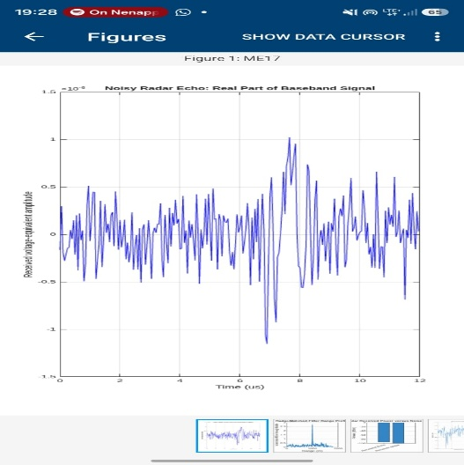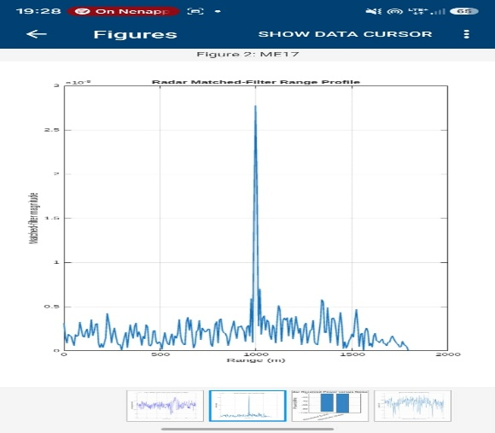

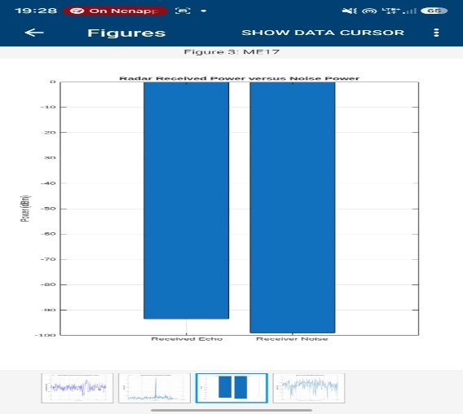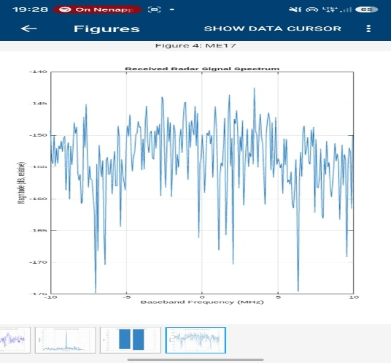

Result:
The microwave radar system was simulated successfully. Target detection and range estimation were performed using the time delay of the received signal. The received-signal characteristics, including amplitude, noise level, and SNR, were analyzed to evaluate the overall radar performance.

